**1. Write a program to find the mean, mode and median of the given range of numbers.**

**Source Code:**

l=[]  
n=int(input("Enter number of elements: "))  
print("Enter the elements: ")  
for i in range(n):  
 a=int(input())  
 l.append(a);  
print("The elements are:")  
print(l)  
  
l.sort()  
  
print("Mean: {0}".format(sum(l)/n))  
if n%2!=0:  
 print("Median: {0}".format(l[n//2]))  
else:  
 print("Median: {0}".format((l[n//2]+l[n//2-1])/2))  
max=0  
count=0  
dict={}  
for i in l:  
 if i in dict:  
 dict[i]+=1;  
 else:  
 dict[i]=1;  
max=0  
for i in dict:  
 if(dict[i]>max):  
 max=dict[i]  
 mode=i;  
print("Mode: {0}".format(mode))

**Output:**

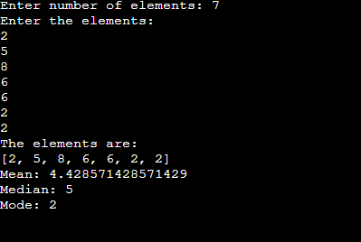

**2. Write a program to calculate the standard deviation of a given set of numbers.**

**Source Code:**

l=[]  
n=int(input("Enter number of elements: "))  
print("Enter the elements: ")  
for i in range(n):  
 a=int(input())  
 l.append(a);  
print("The elements are:")  
print(l)  
mean=sum(l)/n;  
l1=[];  
for i in l:  
 a=(mean-i)**2  
 l1.append(a)  
variance=sum(l1)/n;  
std_dev=variance**0.5;  
print("Variance: {0}".format(std_dev))

**Output:**

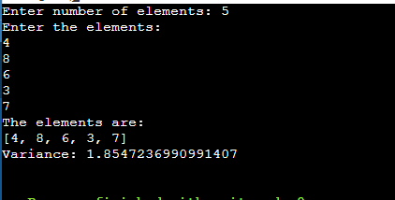

**3. Write a program to calculate the addition of two 3x3 matrices.**

**Source Code:**  
print("Enter elements of first matrix")  
matrix1=[]  
for i in range(3):  
 l=[]  
 for j in range(3):  
 a=int(input())  
 l.append(a)  
 matrix1.append(l)  
  
print("Enter elements of second matrix")  
matrix2=[]  
for i in range(3):  
 l=[]  
 for j in range(3):  
 a=int(input())  
 l.append(a)  
 matrix2.append(l)  
  
i=0  
j=0  
matrix3=[]  
while i<3:  
 m=[]  
 for x in range(3):  
 sum=matrix1[i][x]+matrix2[i][x];  
 m.append(sum)  
 matrix3.append(m)  
 i+=1  
  
print("First Matrix: ")  
for i in matrix1:  
 print(i)  
print("Second Matrix: ")  
for i in matrix2:  
 print(i)  
print("After Addition: ")  
for i in matrix3:  
 print(i)

**Output:**

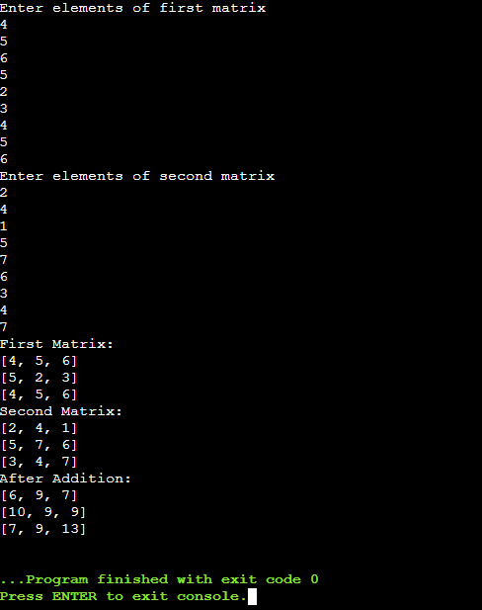

**4. Write a program to calculate the multiplication of two 3x3 matrices.**

**Source Code:**

print("Enter elements of first matrix")  
matrix1=[]  
for i in range(3):  
 l=[]  
 for j in range(3):  
 a=int(input())  
 l.append(a)  
 matrix1.append(l)  
  
print("Enter elements of second matrix")  
matrix2=[]  
for i in range(3):  
 l=[]  
 for j in range(3):  
 a=int(input())  
 l.append(a)  
 matrix2.append(l)  
  
i=0  
j=0  
matrix3=[]  
for i in range(3):  
 lis=[]  
 for j in range(3):  
 sum=0  
 for k in range(3):  
 sum+=matrix1[i][k]*matrix2[k][j];  
 lis.append(sum)  
 matrix3.append(lis)  
  
  
print("First Matrix: ")  
for i in matrix1:  
 print(i)  
print("Second Matrix: ")  
for i in matrix2:  
 print(i)  
print("After Multiplication: ")  
for i in matrix3:  
 print(i)

**Output:**

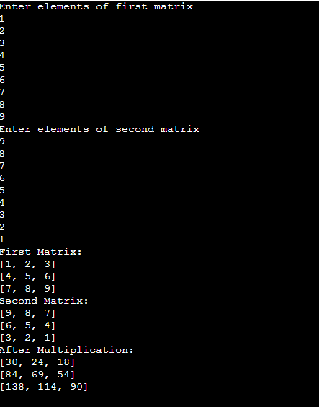

**5. Write a program to calculate the transpose of the given matrix.**

**Source Code:**

print("Enter elements of matrix")  
matrix1=[]  
for i in range(3):  
 l=[]  
 for j in range(3):  
 a=int(input())  
 l.append(a)  
 matrix1.append(l)  
  
print("Matrix: ")  
for i in matrix1:  
 print(i)  
  
for i in range(3):  
 for j in range(3):  
 if(j>i):  
 temp=matrix1[i][j]  
 matrix1[i][j]=matrix1[j][i]  
 matrix1[j][i]=temp;  
  
print("Transpose of Matrix: ")  
for i in matrix1:  
 print(i)

**Output:**

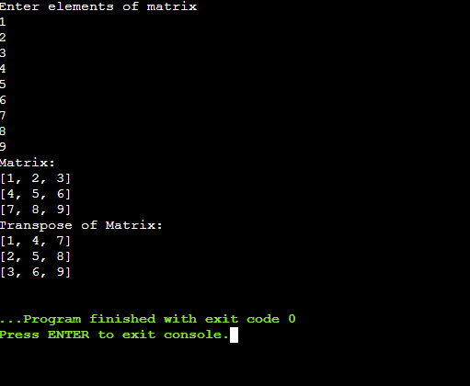

**Q6-write a programe to inverse a matrix**

**Source code**

import numpy as np

A = np.array([[6, 1, 1],

[4, -2, 5],

[2, 8, 7]])

print(np.linalg.inv(A))

**output-**

